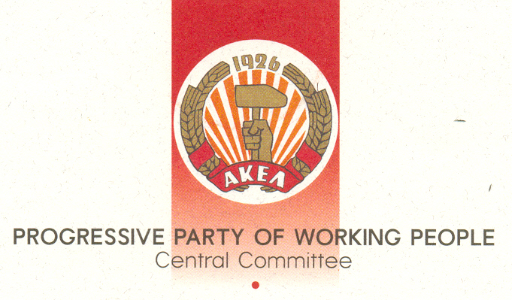

Contribution by AKEL
to the meeting of European Communist and Workers' Parties

Vera Polycarpou, member of the C.C. AKEL
30th September 2013, Brussels

On behalf of the C.C. of AKEL I welcome today's meeting organized on the initiative of the Communist Party of Greece. The Communist Movement needs to take these initiatives at all levels in order to assess the experience which our parties have accumulated; to study the general conditions and the situation in the countries where each party separately develops its activity, but also to exchange views on how to strengthen our struggle.

The crisis of capitalism is general. This is shown by all the figures on the basis of economic life. Just recently "Forbes" magazine estimated that the group of the richest businessmen in the world, five years after the crisis, have won back everything they had lost. At the same time, the 400 wealthiest Americans have amassed wealth equal to the Gross Domestic Product of Russia, a country with a population of over 143 million inhabitants.

The exposure of the real causes of the crisis, against the current in the mass media too, is our primary goal and purpose. The reality is that the myth of free competition has collapsed. On its ruins, the powerful monopoly conglomerates are being maintained and supported, whilst Small and Middle Business´ are closing down at a fast rate. The recession, also due to the policy implemented is continuous, while any development is of course unequally distributed. Instead, the only variable are the reserves of the unemployed and underemployed that are multiplying. The crisis will deepen and worsen, in the sense that monopolies are growing even stronger, while those states that are dominant powers in the international correlation of forces will be impose their interests and policies on dependent states.

The ruling class, the centres channelling ruling systemic thinking, think tanks but also the European Union itself agree on many issues. But there is one thing which in our opinion is predominant in this agreement, namely what "Forbes" magazine wrote in February 2012: "the crisis of capitalism is a crisis of a lack of capitalism."

It is for this reason that the decisions at an all-EU level, their implementation and programs approved by the EU governments constitute nothing but a generalized attack on the people that is assuming various forms but with a uniform character. The consistent revelation of the character and policies of the European Union and the Euro zone, through the disclosure of the substance of the decisions and policies pursued, will vindicate sooner or later our assessments in the minds of the people. The time towards the upcoming European Elections in May is a time where the popular strata, SME´s, women, young people and pensioners will feel even more tangible the consequences of the policies of the European Union; the Lisbon Treaty and the direction for unbridled competition and the further deepening of the relations with NATO and militarization; the so-called single governance through the strict enforcement of the Stability Pact.

It our duty to work so that the people would be able to establish an event more direct way how the decision for the direct subordination of the national budgets of states to the Directorate of Brussels is being enforced in practice. The people should be helped to equate the so-called golden rule for budget surplus in the budgets with the attacks on education, the privatizations, the complete surrendering of free primary health to private capital.

It is through the "Euro Plus" Agreement or the previous Lisbon Strategy when the imposition of reduction in labour costs in a holistic manner was agreed by all means. This is an attack which the working classes, and even the small shopkeepers, are experiencing in a violent and systematic way. These are the policies of "more capitalism", monopoly capitalism which are leading to the widespread poverty. Of course the real solution is not the return to a "soft" capitalism. This option is rejected first and foremost by the forces of the system, the system itself and by its very character. Humanity's real historical choice is socialism.

Dear comrades,

The road is obviously complex and difficult. AKEL´s position is that the specific conditions in each country demand tactics, the organization of resistance, the forging of social and popular alliances with agencies and organizations, the unity in action through the best possible guidance from the political party. In addition, patriotic political forces need to be really utilised. It is our assessment that resistance, the organized struggle against the offence on the working people's rights, against the curbing of basic liberties, and their political projection in a way that demonstrates our demand to halt the attack are vital elements in strengthening our position and struggles, but also in implementing of our ideology.

Furthermore, we believe that the struggle to win the rights working people are loosing, our own fierce and well-documented opposition to the privatization of public organizations and the commercialization of goods does not mean that we are choosing the system, but that we are struggling for the survival of an elementary living standard. . The interconnection of this struggle with the capitalist crisis and its real causes, the projection of demands that touch the very nature of the exploitative system create the consciousnesses that challenge the ideological arsenal of the advocates of the capitalist system. Fundamental proposals that explain the role of the Stability Pact, the Treaty of the EU itself which explain reality in a class way contribute towards the reversal and winning the hearts and minds in favour of the forces of socialism. The confrontation with social democracy that has preserved and strengthened the exploitative economic system and aspires to play exactly the same role today, although weakened by its complete identification with the Right, is definitely a prerequisite.

Comrades,

Before us the ghost of Nazism - Fascism is being projected all the more powerfully, regardless of any differences in their size in each country. The deadlocks of the system and the policy of facilitating and tolerating these movements are fermenting the poisonous fruits of fascism. The Communists are consistent fighters in the struggle against fascism and neo-Nazism. They are unwavering opponents of scientific attempt to equate fascism with our ideology, an attempt being made with the participation of the EU.

And of course, high on our priorities is the issue of the struggle against militarisation and war. Particularly what concerns the area of the Middle East and the Eastern Mediterranean, which concerns us highly not least because part of Cyprus continues to be under Turkish occupation. For the lack of time, I just reiterate our already expressed position against imperialist wars and intervention.

Finally, allow me to make two references. In connection to the 2014 election for the European Parliament, AKEL's position is that we need to support and improve the GUE / NGL group in the European Parliament, to fight for a greater respect of its confederal character. Secondly, we express the hope that the upcoming Meeting of the Communist and Workers' Parties in Lisbon will chart a path for the further strengthening of our struggle and cooperation of our cooperation, to specify actions, substantially assist our struggle on the side of the working class.

We express our solidarity with the parties present in their struggles in favour of their peoples.

